IEA DH&C Project:
Improvement of operational temperature differences in district heating systems

Working document

TYPES OF MALFUNCTIONS IN DH SUBSTATIONS

Håkan Walletun

ZW 2004-02-04
Energiteknik ZW - 04/06

Types of malfunctions in DH substations

District heating substations which on an annual average exhibit a temperature difference lower than ca 30°C can be suspected to suffer of some kind of malfunction. This malfunction can be found either in the substation itself or in the system connected to it, f. i. the radiator or tap hot water system. Some of these malfunctions can have impact on the delivered heating power or domestic hot water temperature, or else impair the comfort of the customer. For the district heating customer it might be very often be equally interesting to get rid of these malfunctions as it is the case for the heat deliverer. Very often, malfunctions cannot safely be identified by the cooling properties of a substation. In this case, additional diagnostic methods must be applied.

We can conclude that a main class of malfunctions exist, which only impairs the cooling (temperature difference) of substations and another class, which impairs both cooling of substations and the comfort of the customer.

There are many reasons for malfunction of a DH substation. Defects can be built in under installation or repair of a substation, due to wrong design or choice of components. Defects can occur due to aging or wear of a components. Malfunction can occur due to choice of unsuitable control parameters in the control equipment. Furthermore, the heat application environment can be designed that way that the intended system function cannot be achieved.

Below, the following categories of malfunctions are used:
- R malfunction belonging to the radiator system
- T malfunction belonging to the domestic hot water (tap water) system
- C malfunction belonging to substation components
- E malfunction belonging to system environment.
A differentiation is made between malfunctions impairing the substation cooling and customer comfort. In the Tables 1 – 4 lists with experienced malfunctions are presented for each of the malfunction categories listed above. For component abbreviations, see Figure 1 and explanations in the Figure.
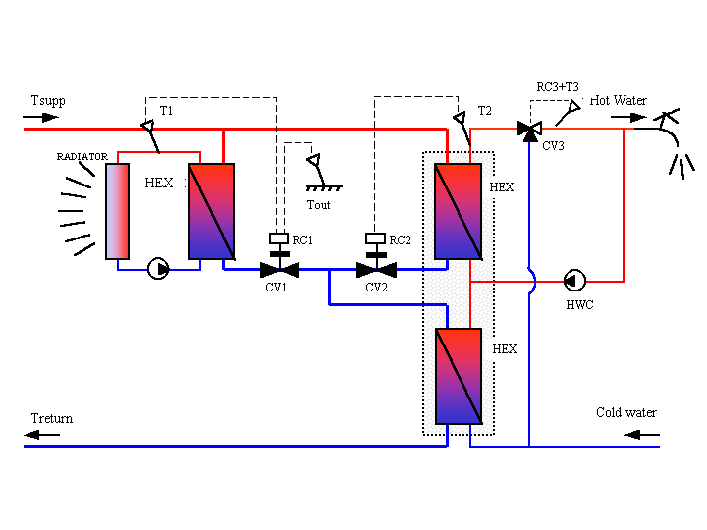
Figure 1: Typical 2-stage substation according to malfunction description.
Explanation:

HEX Heat exchangers
CV1 Control valve radiator system
CV2 Control valve hot water preparation
CV3 Control valve hot water limitation
T1 Radiator temperature sensor
T2 Hot water temperature sensor
T3 Hot water temperature safety limiter
Tout Outdoor temperature sensor
HWC Hot water recirculation

.
Nr | Type of malfunction | Impact on comfort | Impact on SS cooling
R1 | Control valve CV1 manually positioned or closed | yes, often | yes, often
R2 | Control valve CV1 leaking | no | yes
R3 | Soiled heat exchanger | normally not | yes
R4 | Heat exchanger HEX connected in parallel flow (instead of counter flow) | normally not | yes
R5 | Hot water circulation HWC pump not working | yes | not, if CV1 works correctly
R6 | Wrong flow rate (malfunctioning pump or frequency control) | depending on flow rate | depending on flow rate
R7 | Wrong control curve applied | yes | yes, if curve is too high
R8 | Control curve of shunt group less than curve of primary system | yes | yes, often
R9 | Outdoor temperature sensor Tout defect or misplaced | yes | yes, often
R10 | Temp sensor T1 defect or misplaced | yes | yes, often
R11 | Expansion vase empty or leaking heating system | yes | normally not
R12 | Uneven flow distribution among two parallel HEX | no | yes, often
R13 | Short thermal length of radiator or ventilation battery | yes, often | yes
R14 | No radiator thermostat valves available or defect thermostat valves | yes | yes, often
R15 | Uncontrolled radiator flow and/or bypasses | yes, often | yes
R16 | Unsatisfying adjusted radiator system | yes | yes
R17 | Shunted mixing valves in radiator circuit | no | yes

Table 1: Possible malfunctions in the radiator heating system – R - type

Table 2: Possible malfunctions in the tap water system – T - type
Nr | Type of malfunction | Impact on comfort | Impact on SS cooling
T1 | Control valve CV2 manually positioned or closed | yes, often | yes, often
T2 | Control valve CV2 leaking | no | yes
T3 | Soiled heat exchanger | normally not | yes
T4 | Heat exchanger HEX connected in parallel flow (instead of counter flow) | normally not | yes
T5 | Fast HEX combined with slow control valve | yes, often | yes, often
T6 | Hot water circulation pump not working | yes | not, if CV2 works correctly
T7 | Wrong set temperature choice | yes, often | yes, if too high chosen
T8 | Wrong control parameter choice | yes, often | normally not
T9 | Set value RC2 > set value RC3 | no | yes
T10 | CV2 connected in sequence with CV3 | normally not | yes, often
T11 | Temp sensor T2 defect or misplaced (long distance to HEX) | yes | yes
T12 | Short thermal length of hot water HEX | yes, often | yes
T13 | HWC inadequately shunted | no | yes
T14 | Control valve CV3 locked in a given position | depends on control of CV2 | depends on control of CV2
T15 | Control valve CV3 leaking | yes, often | yes
T16 | Temp sensor T3 defect or misplaced | yes, often | yes, often
T17 | HWC is missing, resulting in bad temperature control at low taps | yes | yes
T18 | Wrong HWC flow | yes, if too low | yes, if too high
T19 | Secondary HW make-up with secondary HWC | no | yes

Nr | Type of malfunction | Impact on comfort | Impact on SS cooling
C1 | Wrong or defect HEX | normally not | yes, often
C2 | Wrong or defect control system RC | yes | yes, often
C3 | RC not in operation or electrical malfunction | yes | yes, often
C4 | Wrong or defect valve/motor | yes | yes, often
C5 | Wrong valve size | yes | yes, often
C6 | Blocked filter, primary side | yes | no
C7 | Blocked filter, secondary side | yes | not normally
C8 | Wrong seized flow meter | not normally | yes, if valve authority is affected
C9 | Malfunction of heat meter | no | no
C10 | Malfunction of valves connected in sequence | yes, often | yes

Table 3: Possible malfunctions because of defect components – C – type

Nr | Type of malfunction | Impact on comfort | Impact on SS cooling
E1 | Low district heating supply temperature | yes, if too low | yes
E2 | Secondary use of heat pump or heat recovery system (can cause high return temperatures) | no | yes
Table 4: Possible malfunctions due to erroneous system environment – type E

